# **HTML EXERCISES**

***(*Note: All exercises must be done with pure HTML, you must not use CSS)***

**Figure 1. Exercise 1** 1

**Figure 2. Exercise 2** 2

**Figure 3. Exercise 3** 3

**Figure 4. Exercise 4 - Screen 1** 3

**Figure 5. Exercise 4 - Screen 2** 4

1. **Exercise 1**

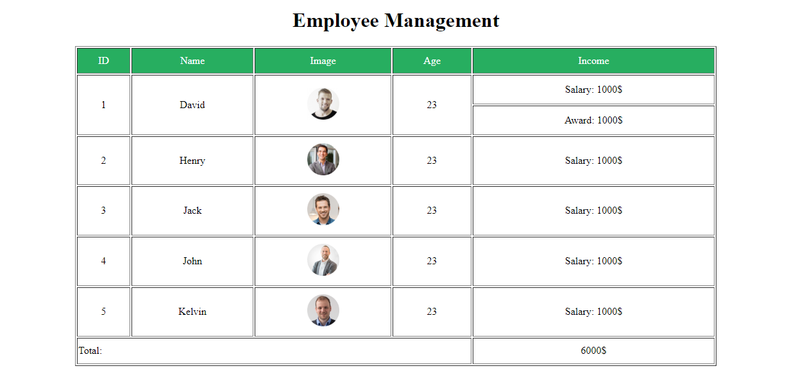

**Figure 1. Exercise 1**

1. **Exercise 2**

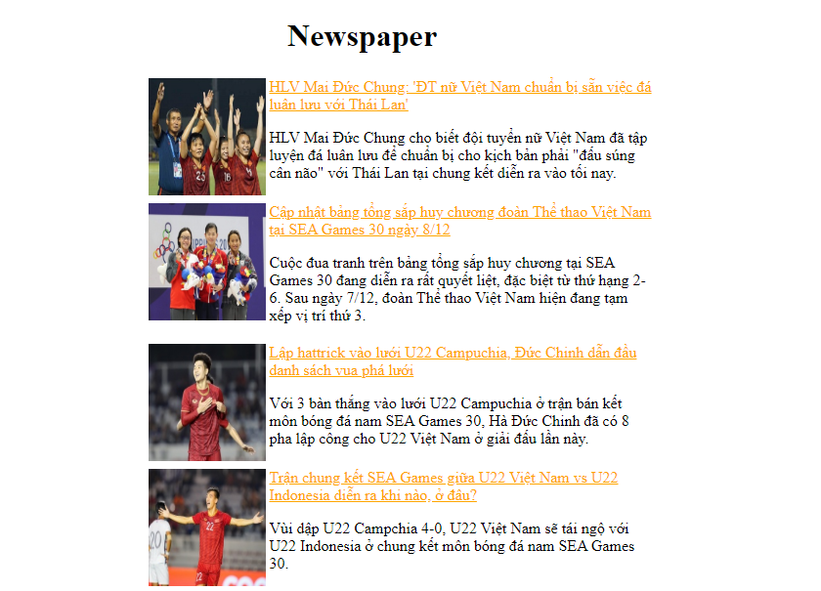



**Figure 2. Exercise 2**

1. **Exercise 3**

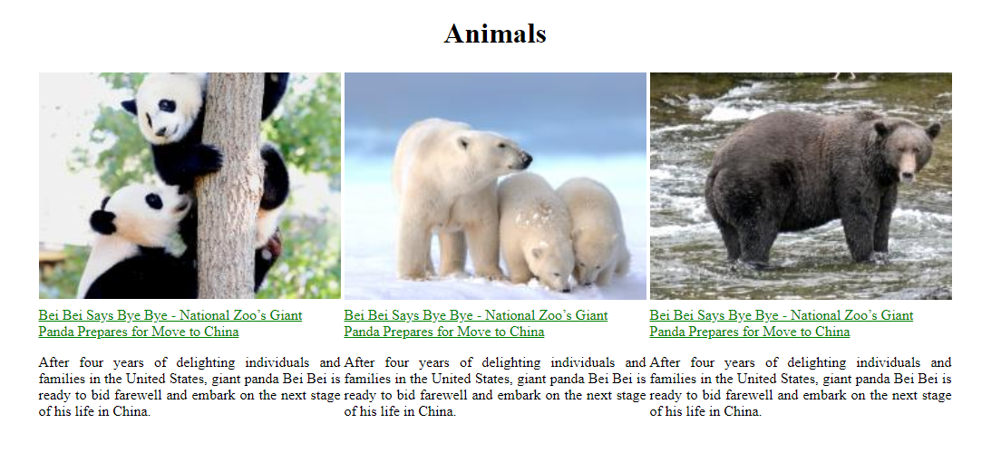

**Figure 3. Exercise 3**

1. **Exercise 4**

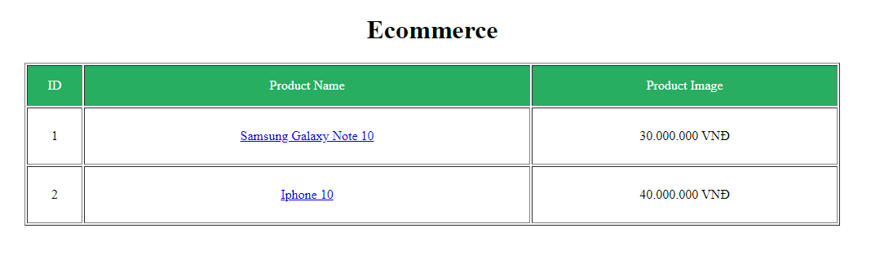

**Figure 4. Exercise 4 - Screen 1**

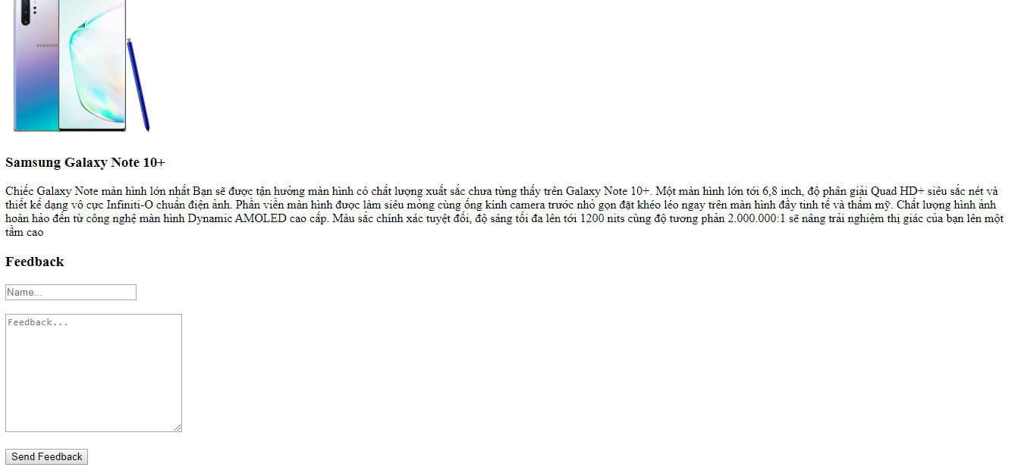

**Figure 5. Exercise 4 - Screen 2**